**Мелехин Александр Кс-30 Вариант 9 Лабораторная работа 1**

**Создание таблиц**

CREATE TABLE salers (

saler_id INT NOT NULL GENERATED ALWAYS AS IDENTITY PRIMARY KEY,

saler_name VARCHAR(100) NOT NULL,

saler_sex VARCHAR(100) NOT NULL,

saler_age INT NOT NULL

);

CREATE TABLE brands (

brand_id INT NOT NULL GENERATED ALWAYS AS IDENTITY PRIMARY KEY,

brand_name VARCHAR(100) NOT NULL

);

CREATE TABLE sales (

sale_id INT NOT NULL GENERATED ALWAYS AS IDENTITY PRIMARY KEY,

sale_date DATE NOT NULL,

brand INT NOT NULL,

price DECIMAL NOT NULL,

sale_count INT NOT NULL,

saler INT NOT NULL,

CONSTRAINT fk_brands_sales FOREIGN KEY (brand) REFERENCES brands (brand_id),

CONSTRAINT fk_salers_sales FOREIGN KEY (saler) REFERENCES salers (saler_id)

);

**Заполнение данных**

**Таблица brands**

INSERT INTO public.brands(brand_name) VALUES ('Самсунг');

INSERT INTO public.brands(brand_name) VALUES ('Леново');

INSERT INTO public.brands(brand_name) VALUES ('Сони');

**Таблица salers**

INSERT INTO public.salers(saler_name, saler_sex, saler_age) VALUES ('Иванов', 'Мужской', '20');

INSERT INTO public.salers(saler_name, saler_sex, saler_age) VALUES ('Петрова', 'Женский', '19');

INSERT INTO public.salers(saler_name, saler_sex, saler_age) VALUES ('Сидорова', 'Женский', '21');

**Таблица sales**

INSERT INTO public.sales(sale_date, brand, price, sale_count, saler) VALUES ('3.1.2005', 1, 12000, 5, 1);

INSERT INTO public.sales(sale_date, brand, price, sale_count, saler) VALUES ('15.1.2005', 2, 8000, 4, 2);

INSERT INTO public.sales(sale_date, brand, price, sale_count, saler) VALUES ('2.2.2005', 1, 25000, 3, 3);

INSERT INTO public.sales(sale_date, brand, price, sale_count, saler) VALUES ('2.3.2005', 1, 10000, 5, 1);

INSERT INTO public.sales(sale_date, brand, price, sale_count, saler) VALUES ('14.2.2005', 3, 11000, 3, 3);

INSERT INTO public.sales(sale_date, brand, price, sale_count, saler) VALUES ('4.4.2005', 1, 19000, 4, 2);

**Результат**

**Таблица brands**

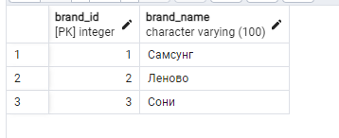

**Таблица salers**

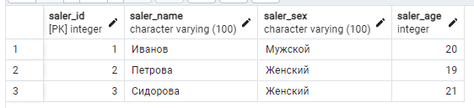

**Таблица sales**

